**SET CONNECT CAPSTONE PROJECT**

***Done By L. ANUSH BHARATHWAJ CSE A***

Hired As An Analytics

A car dealership sells different vehicle models manufactured in one of three regions (US, Europe, and Japan). After collecting a sample of data on cars in their inventory, they have hired your data science and analytics consulting team to provide them insights into their dataset.

1) How do American, European, and Japanese cars differ?

A: a) **CROSSTAB**

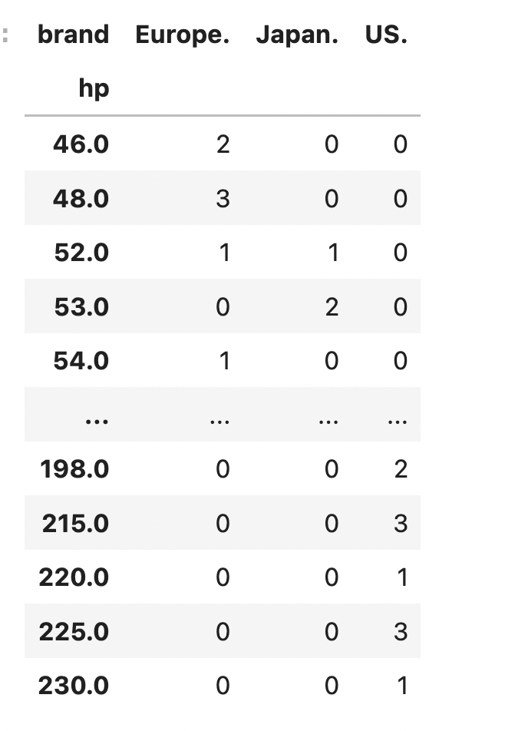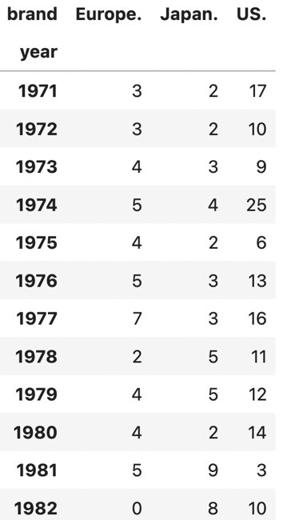

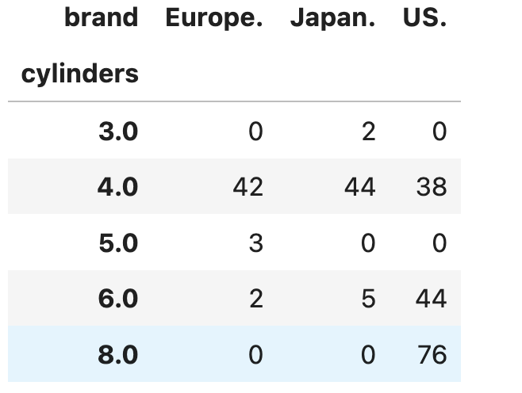

b) **GRAPH**

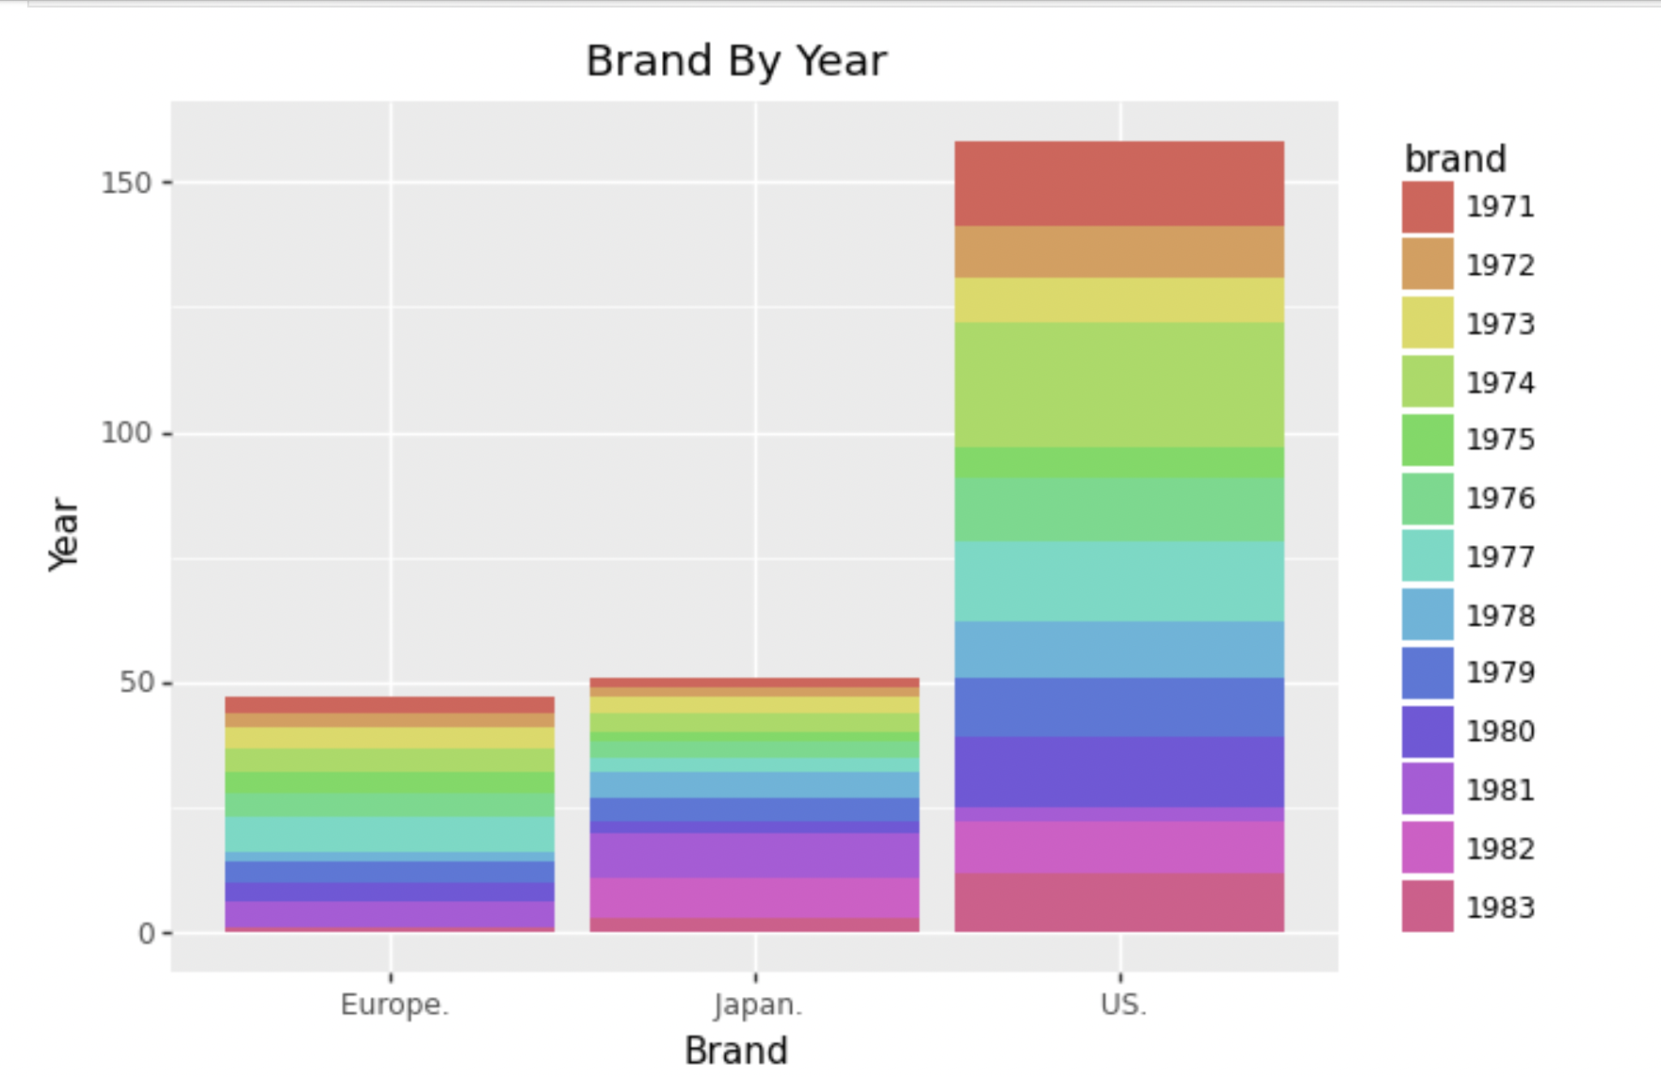

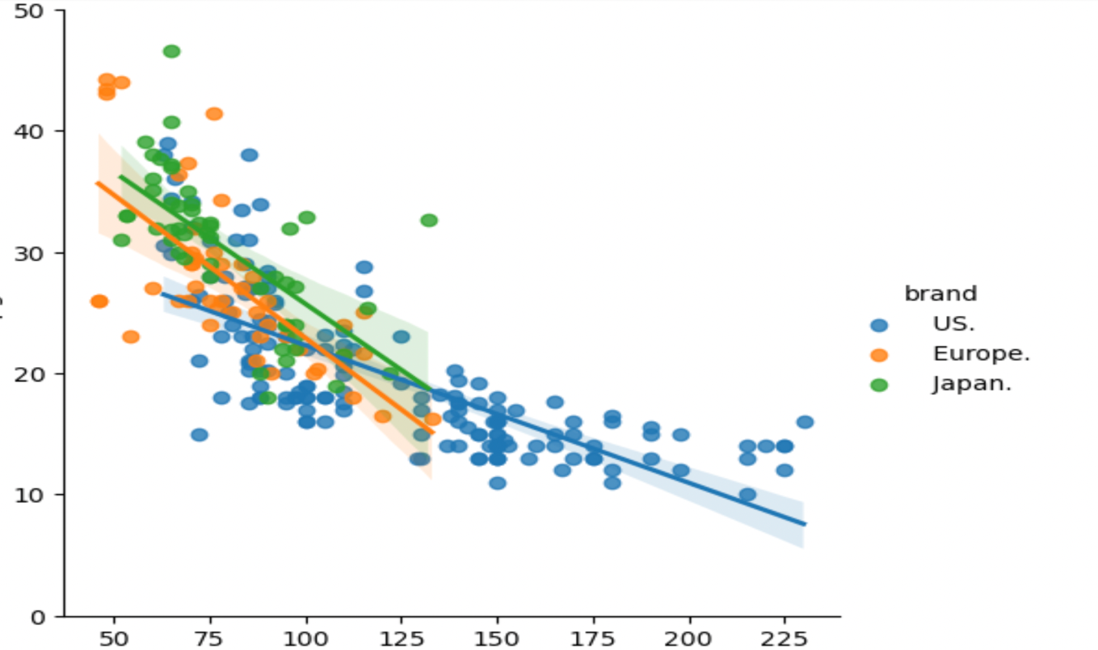

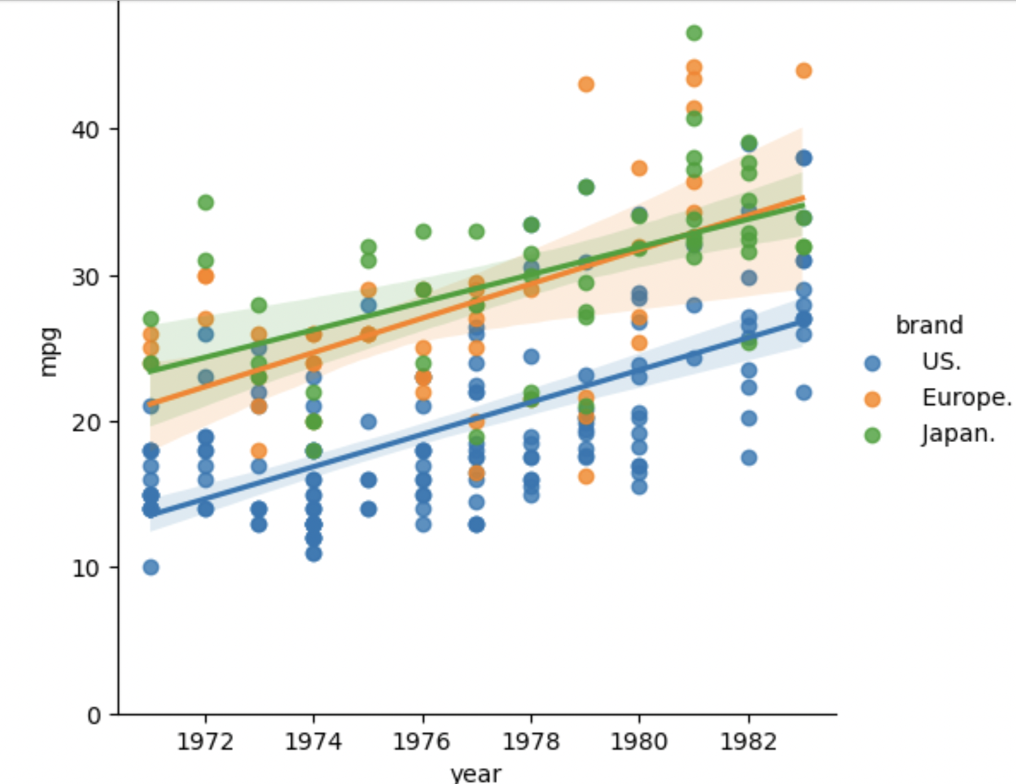

* For America, This should be perfectly obvious—but automotive technologies have changed an awful lot over the last few decades. By graphic proof, here’s a Nifty Chart derived From ggplot Using Plotnine In python. When Comparison To Mpg And Year, The USA produce a less Mpg when Compare To The Japan And Europe. Japan Stay’s In position Over Many Decades. Meanwhile USA Have More Active Years Of Participation When It Comes To Production.

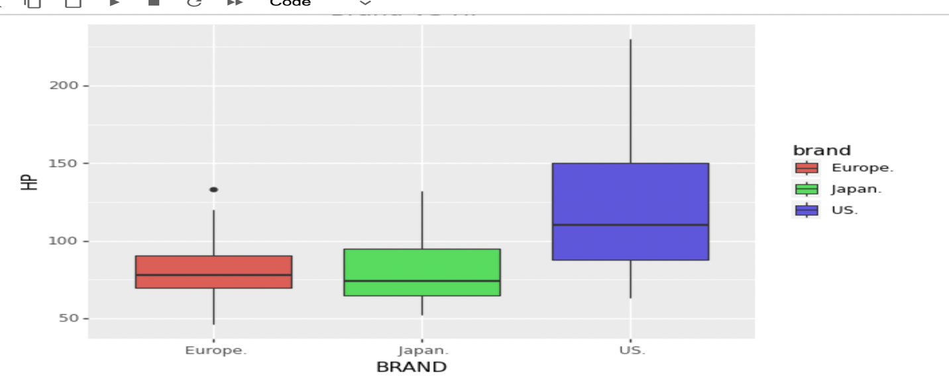

* European Produce Less Hp While It was Compared To Others Japan and US. The US Holds Highest Position For The Production Of Horsepower.

**LOGISTIC REGRESSION MODEL**

**2) Can we build a model to predict which cars are American based on the reported features of the vehicle?**

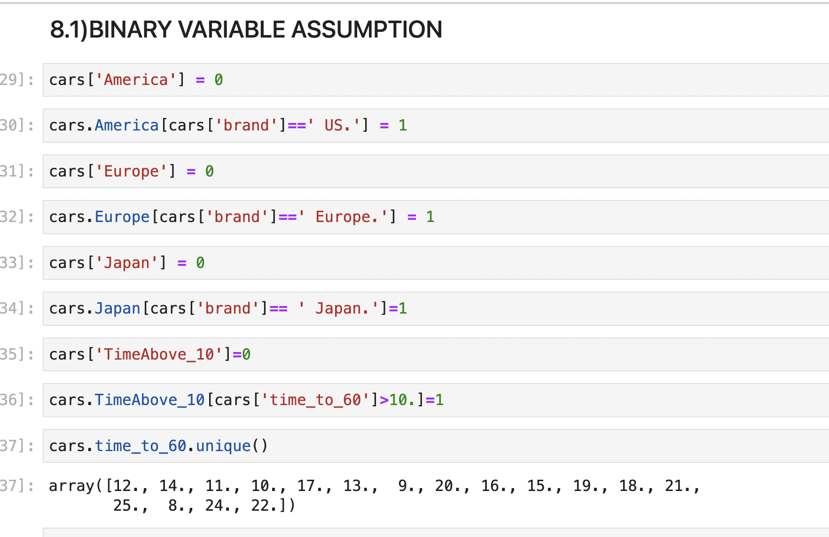

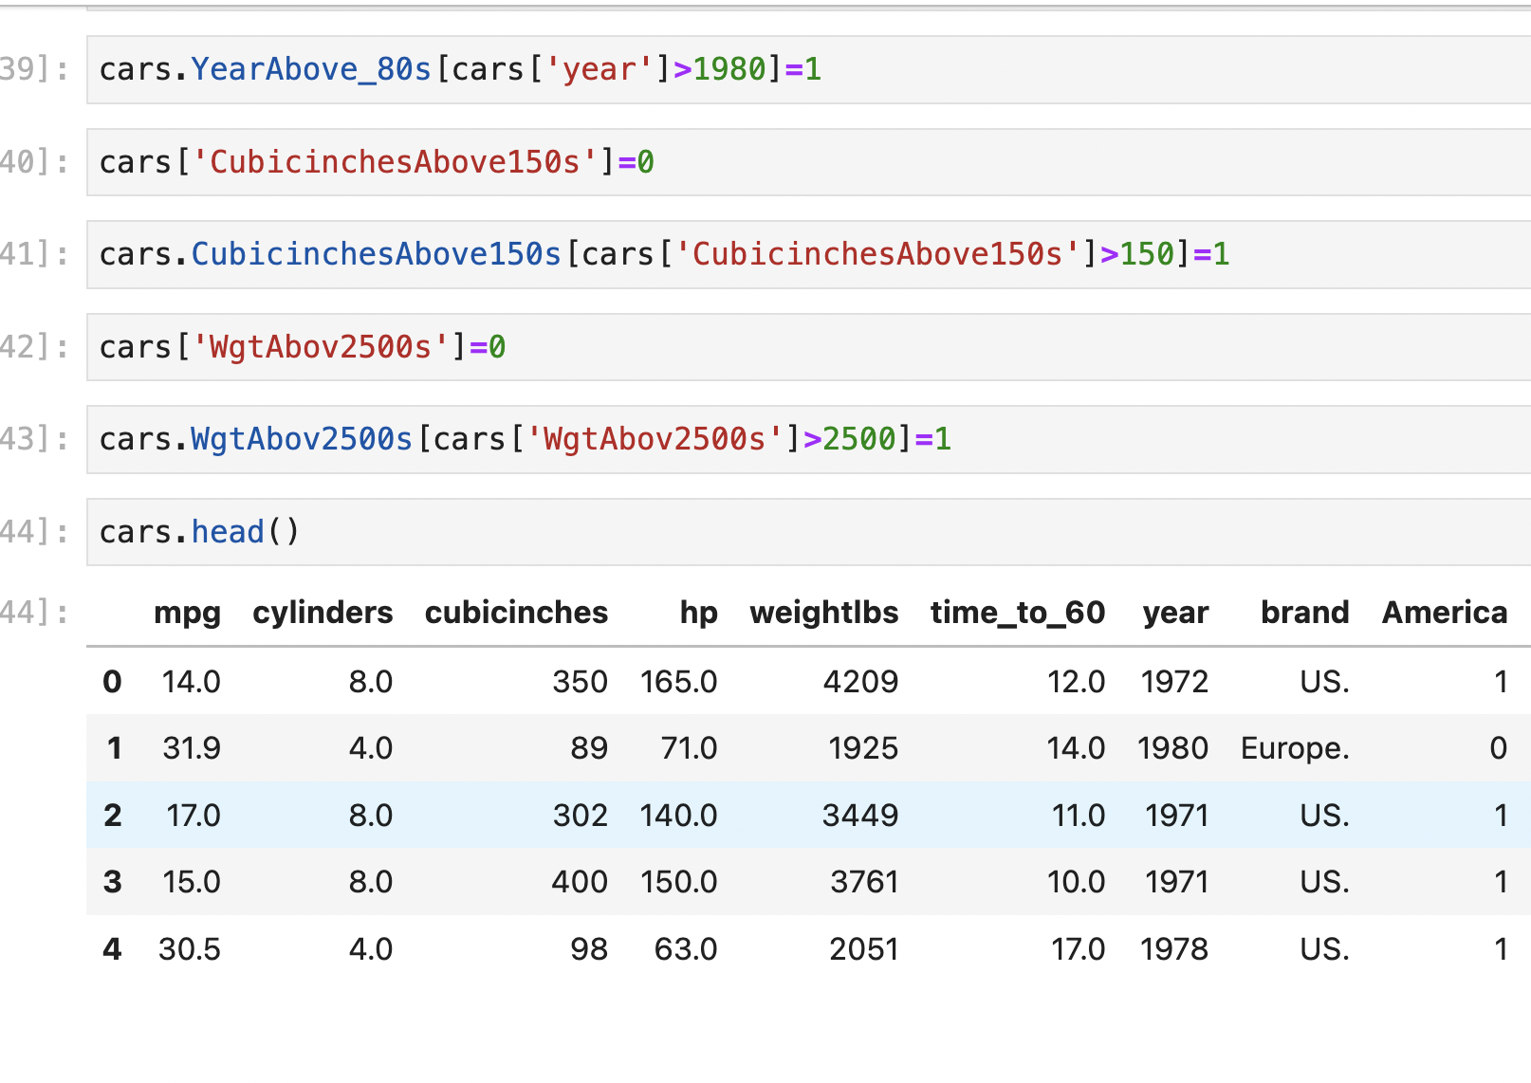

1. Predicting Logistic Models :

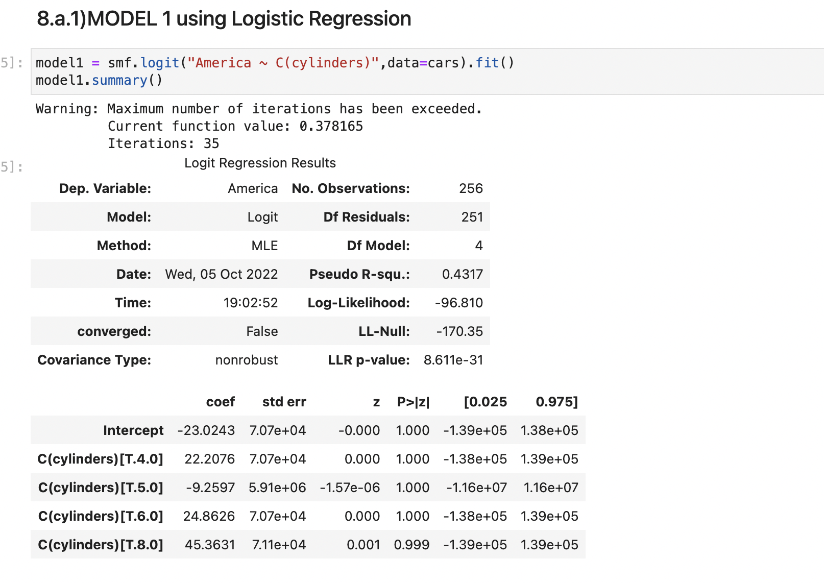

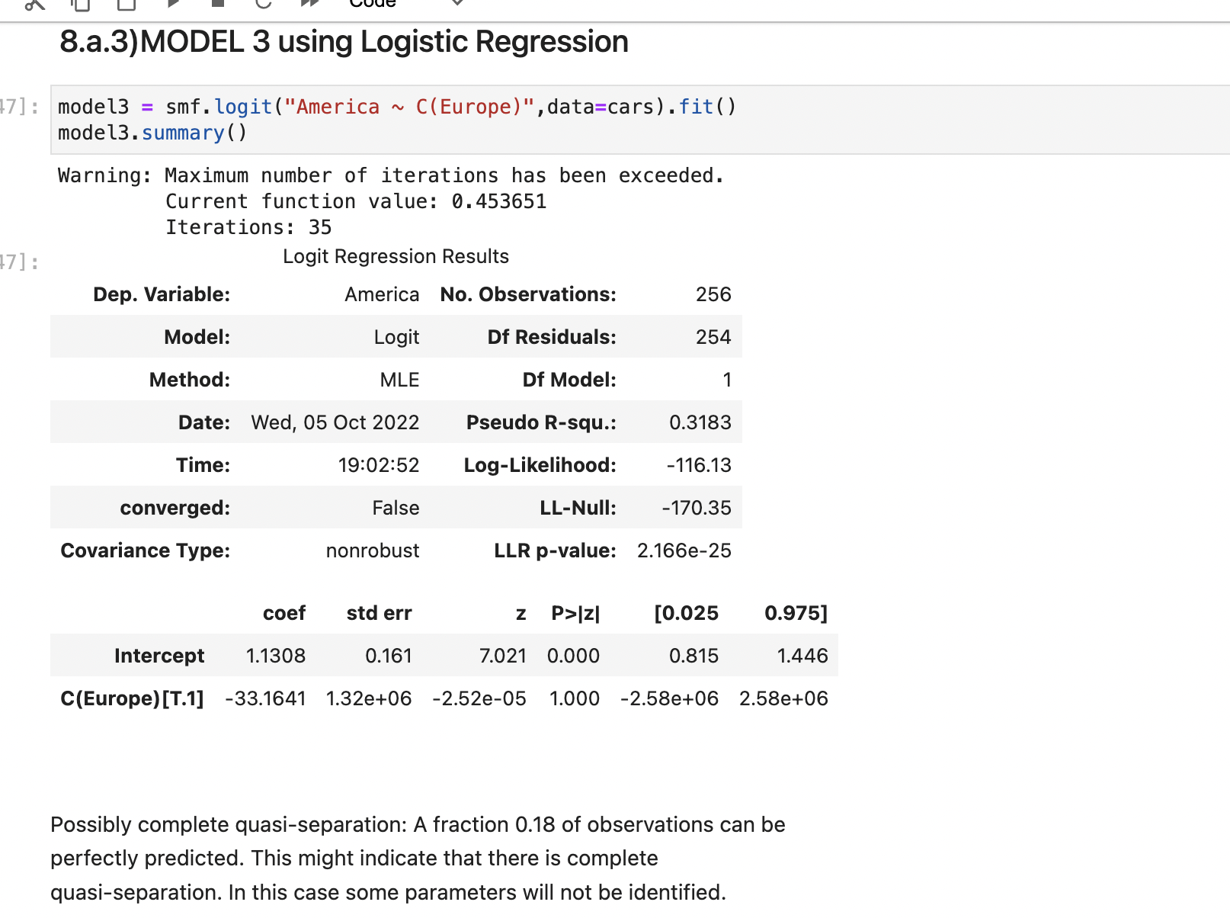

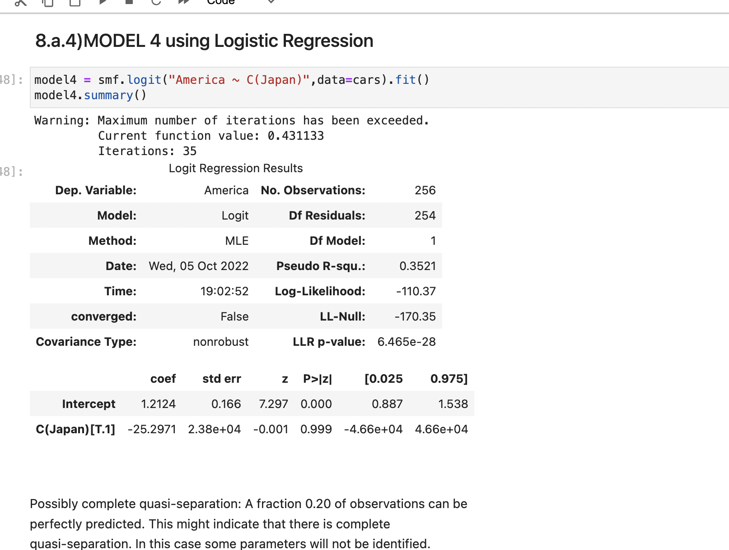

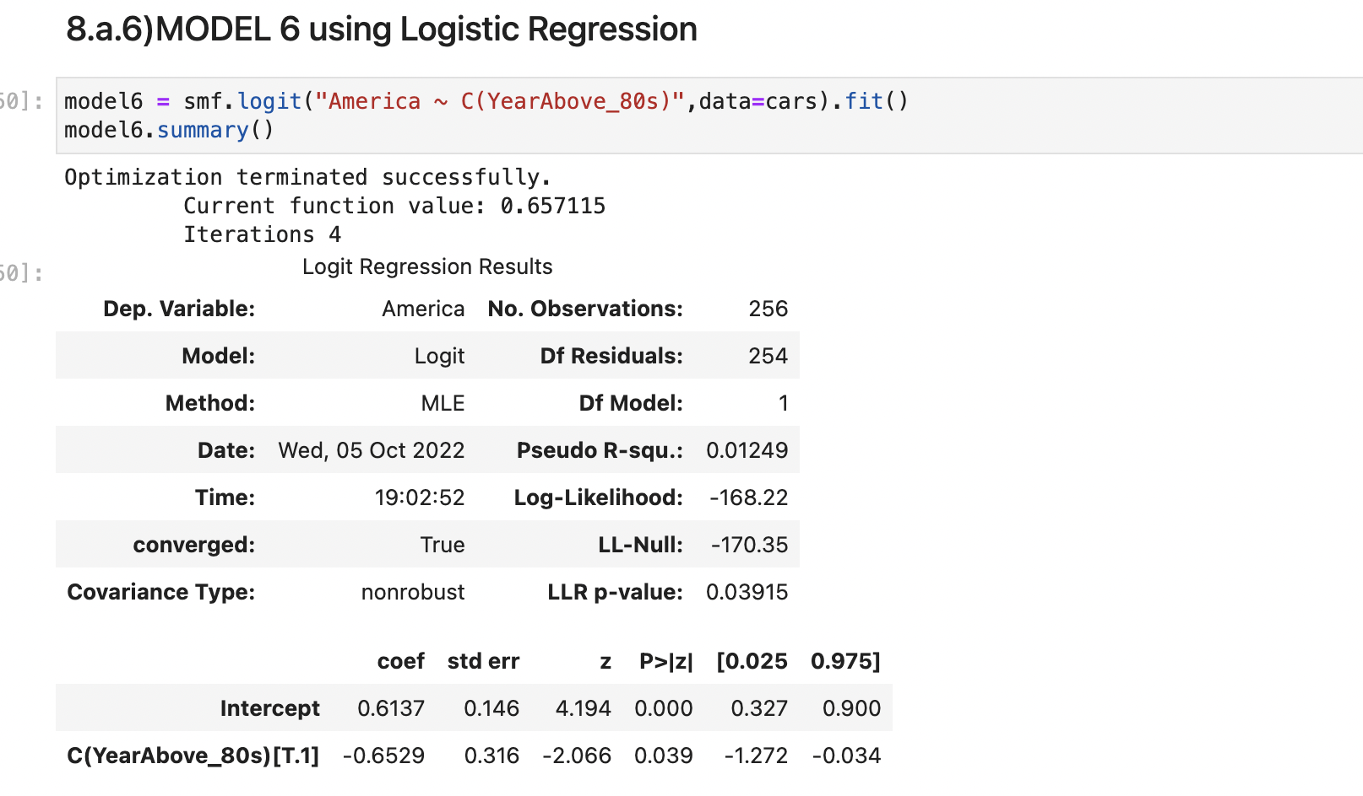

1. Logistic Fit:

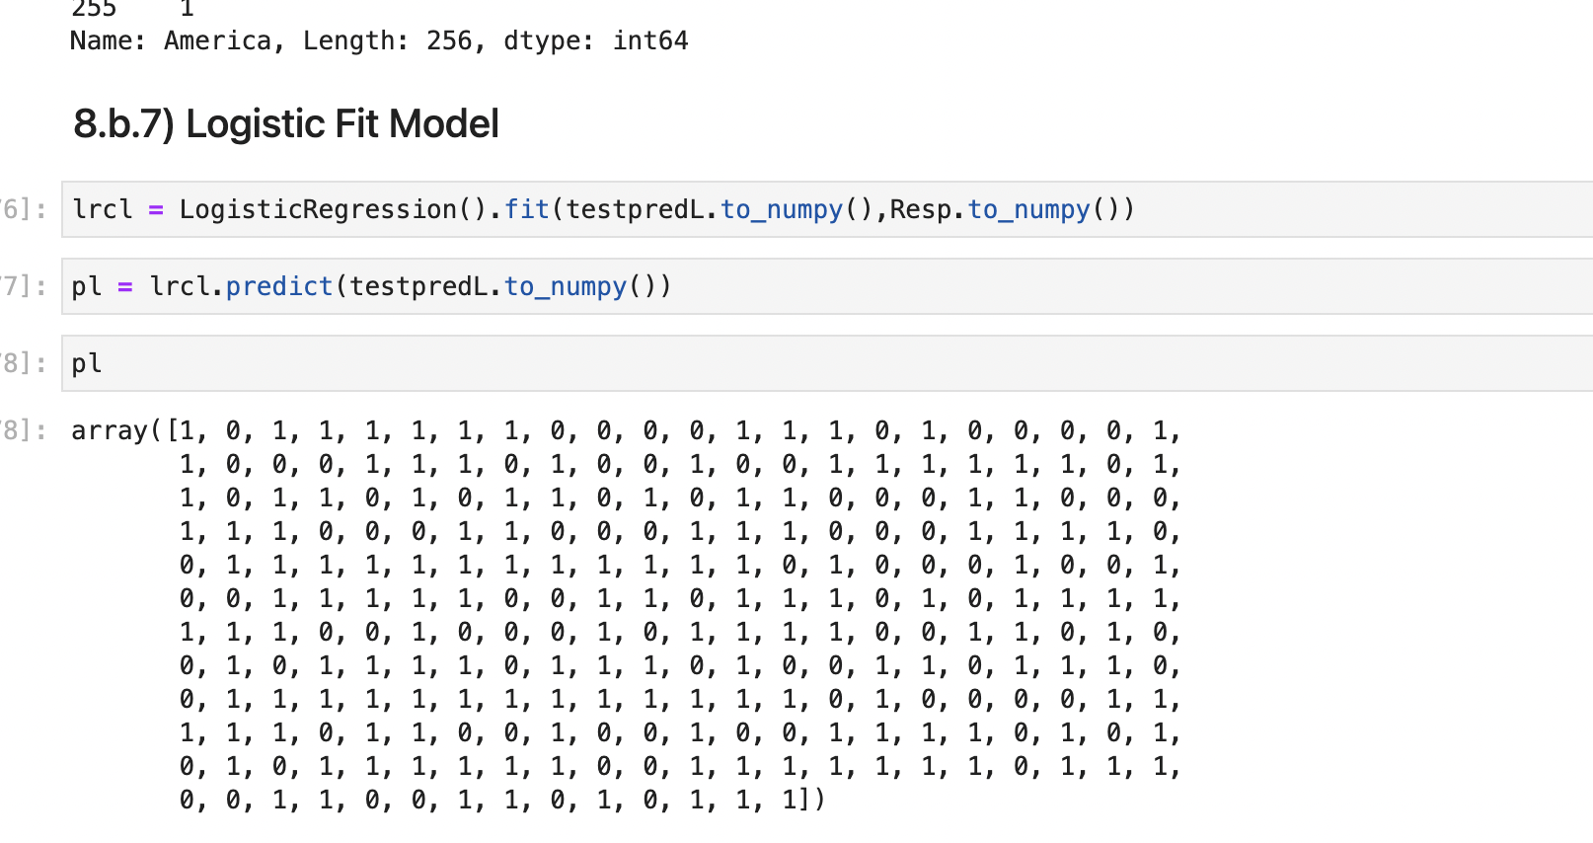

1. Accuracy:

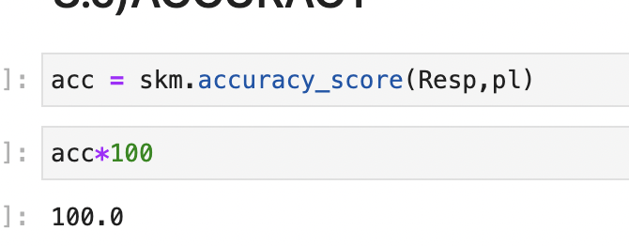

1. Cumulative Probablity Chart:

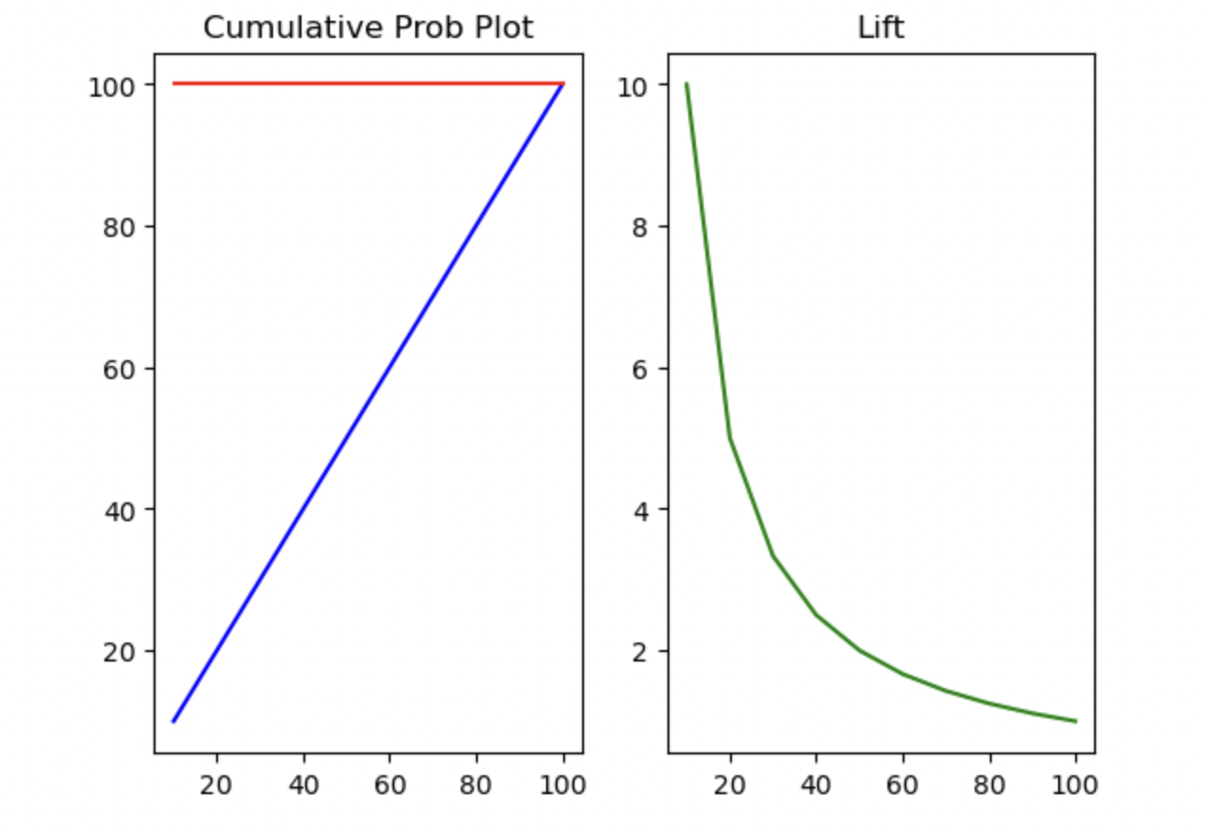

* American Car Can Be Predicted Via By Looking At Hp With Respect To The Year They Manufactured.

**LINEAR REGRESSION MODELS**

1. Linear Regression Model Graph

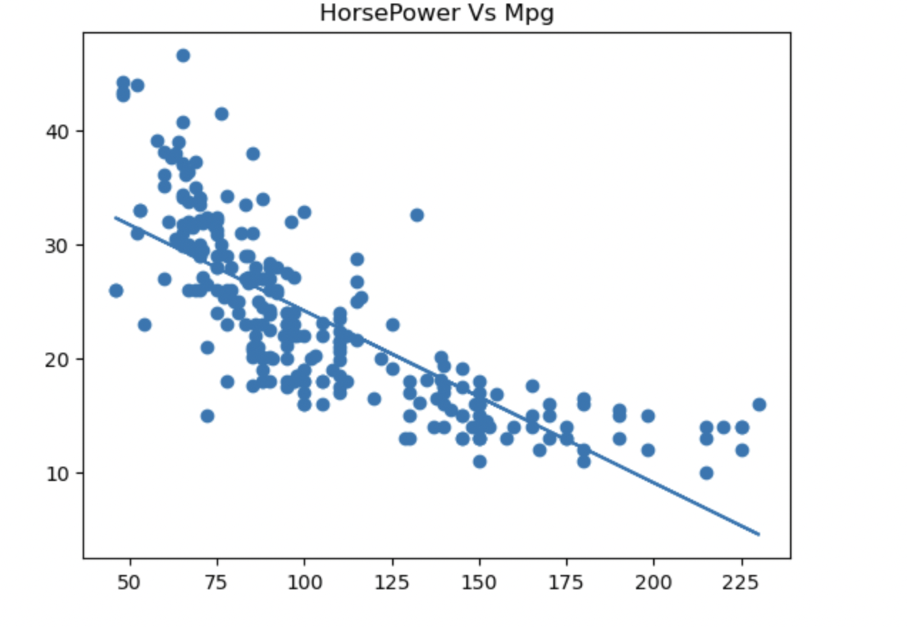

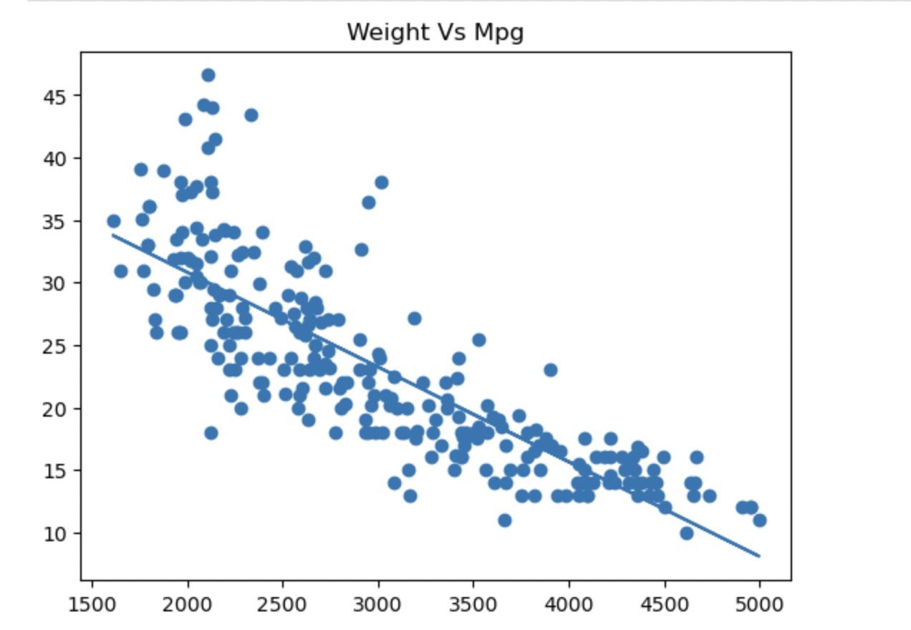

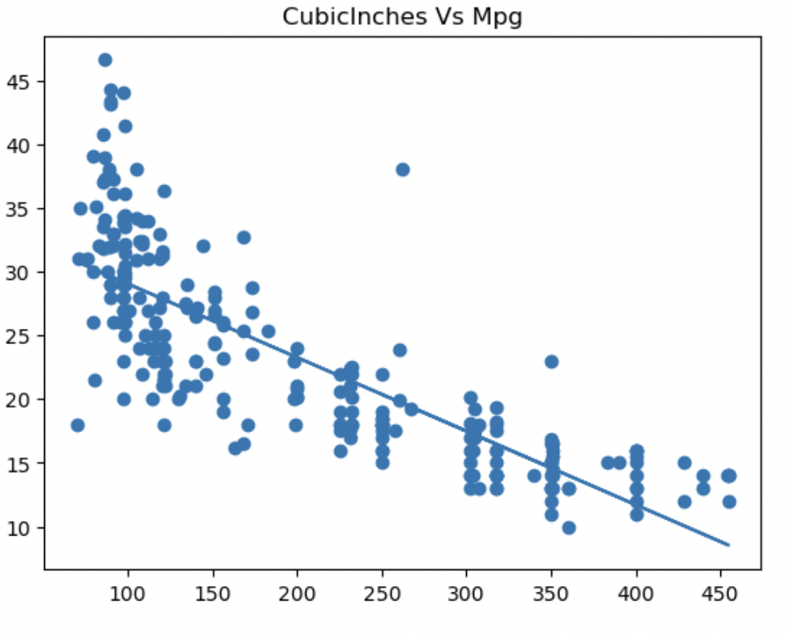

1. Regression Model Using Linear (Stats Model):

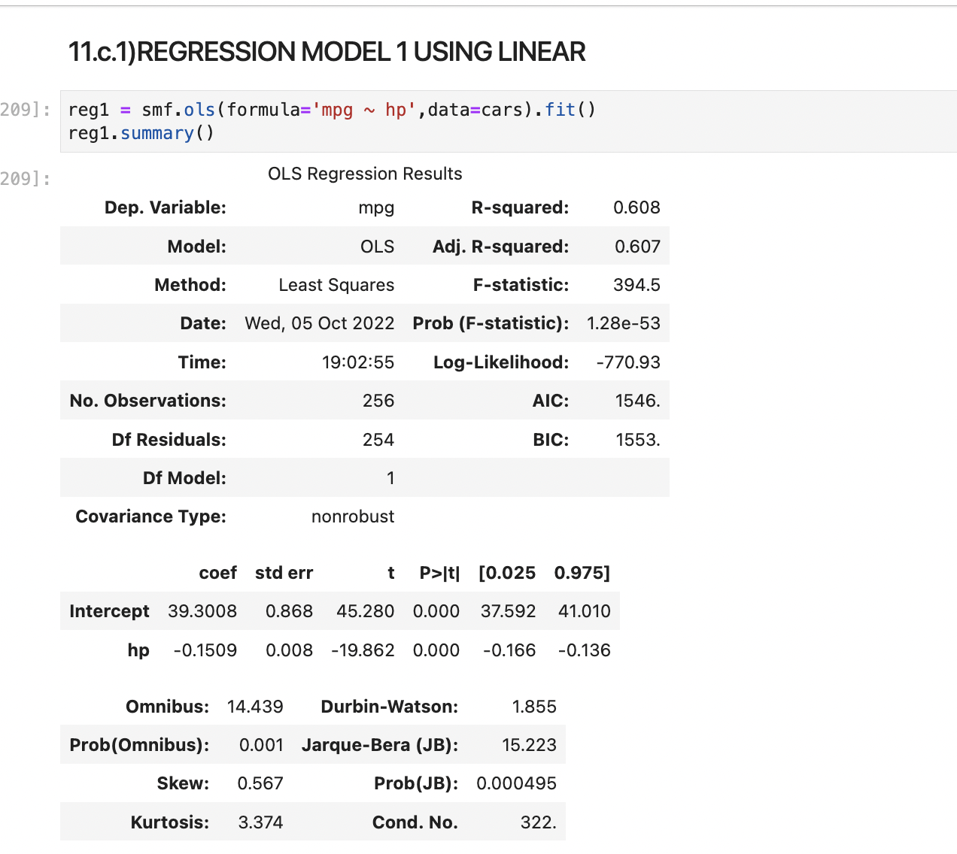

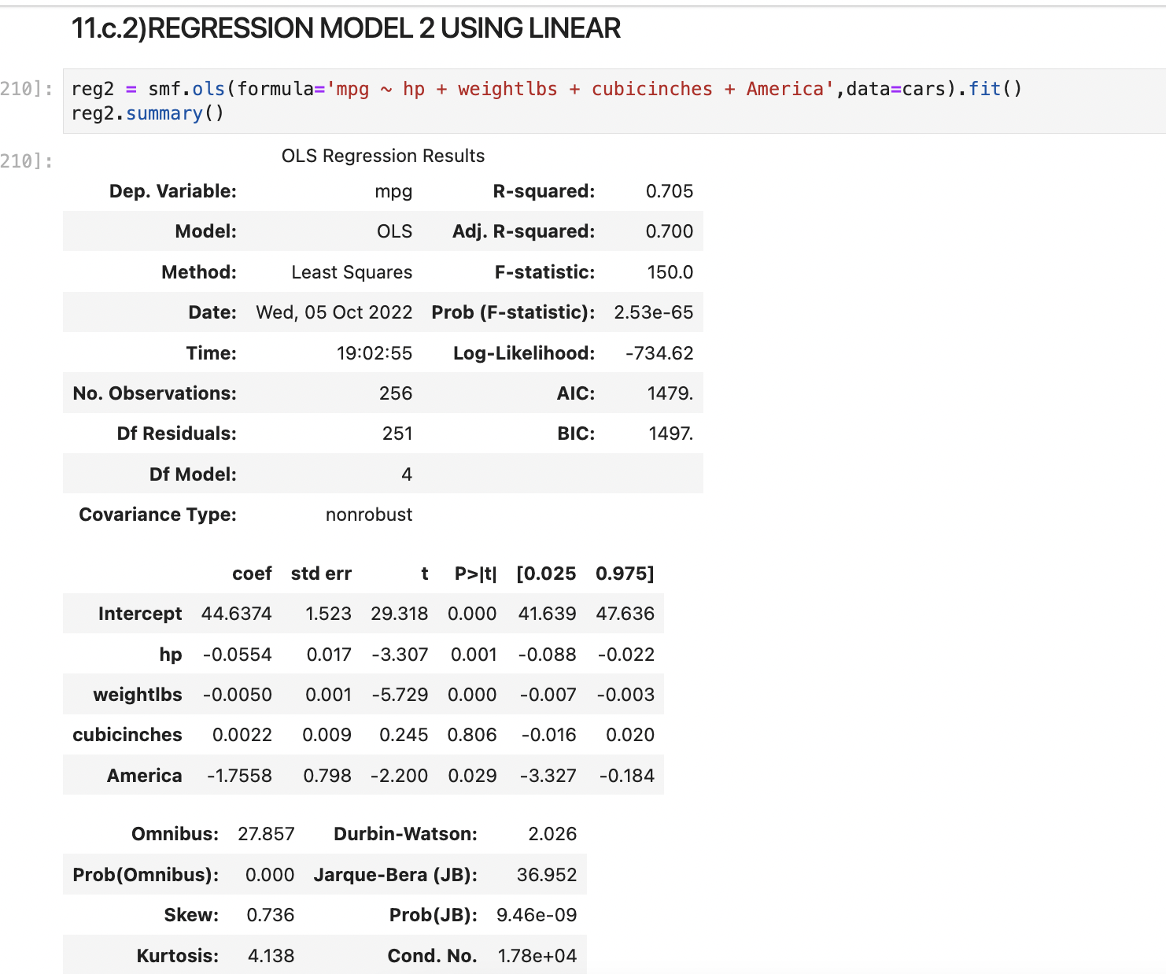

1. LOGIT FUNCTION:

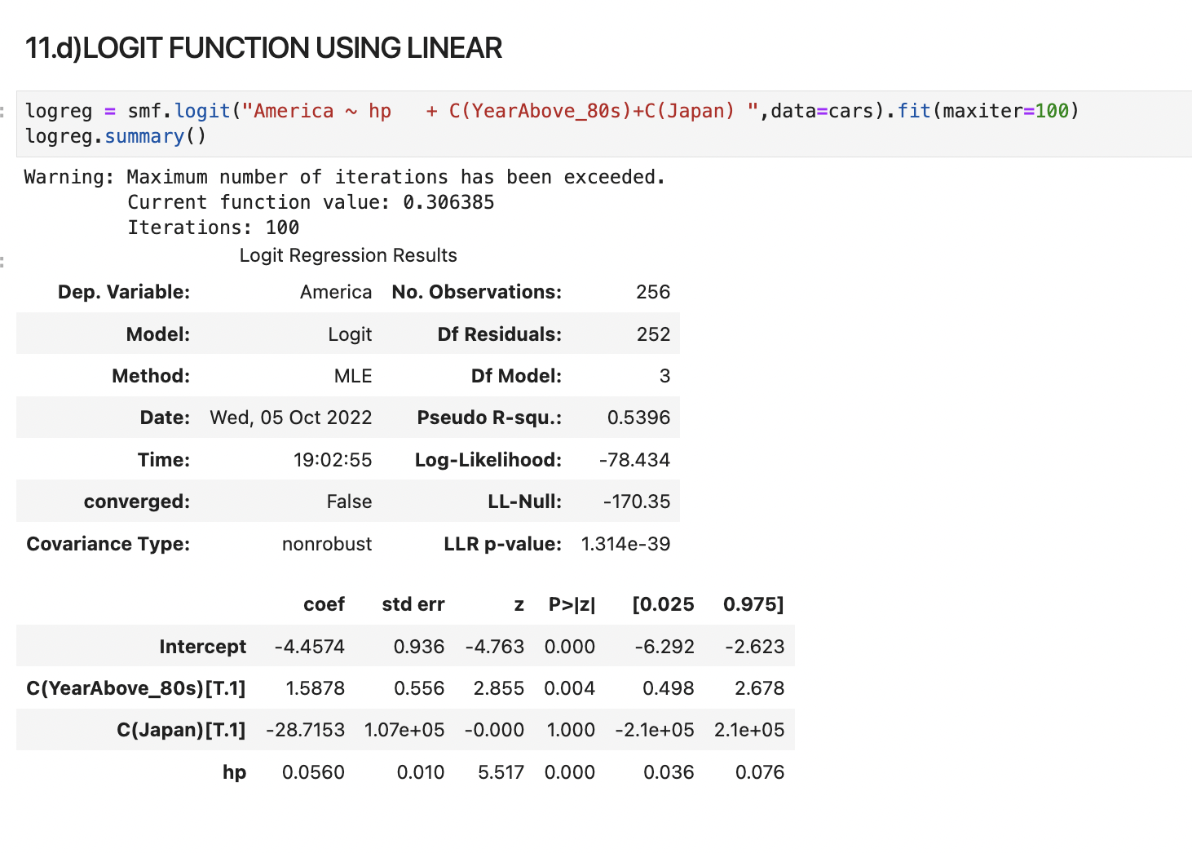

1. True Value Vs Predicted Value :

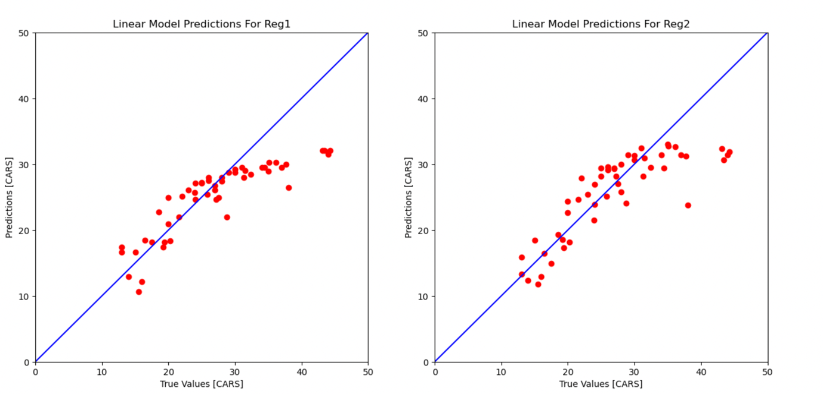

**NON LINEAR REGRESSION MODELS**

1. **Linear Model:**

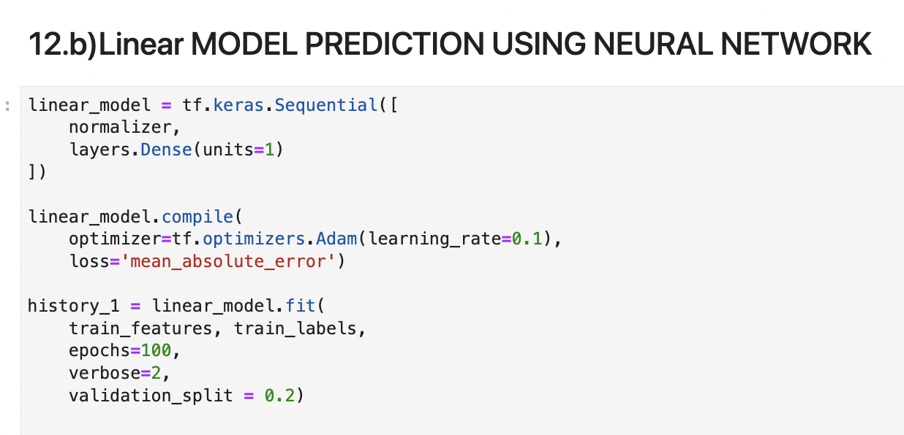

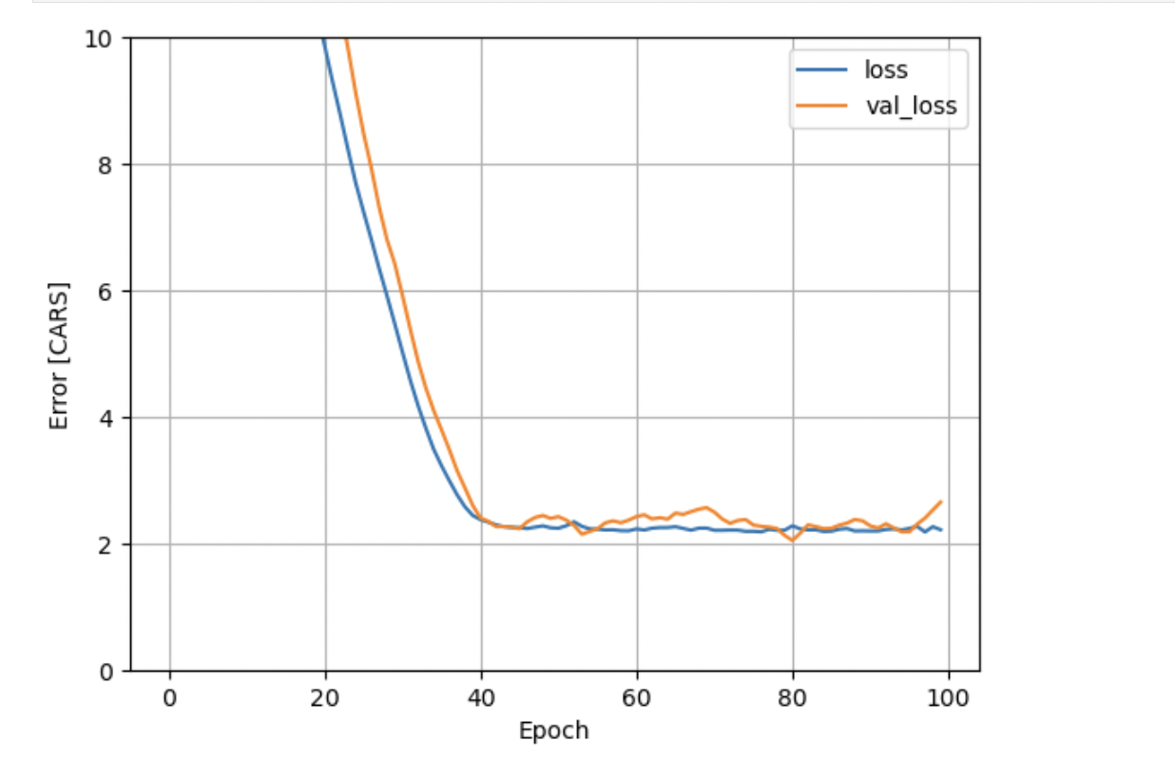

1. **Non Linear Models:**

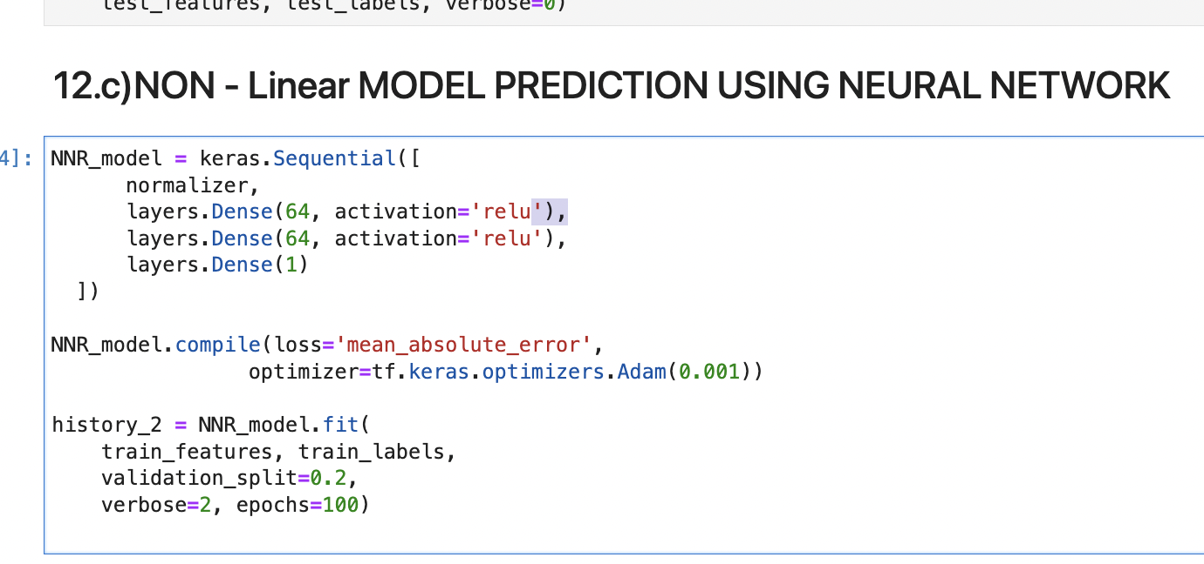

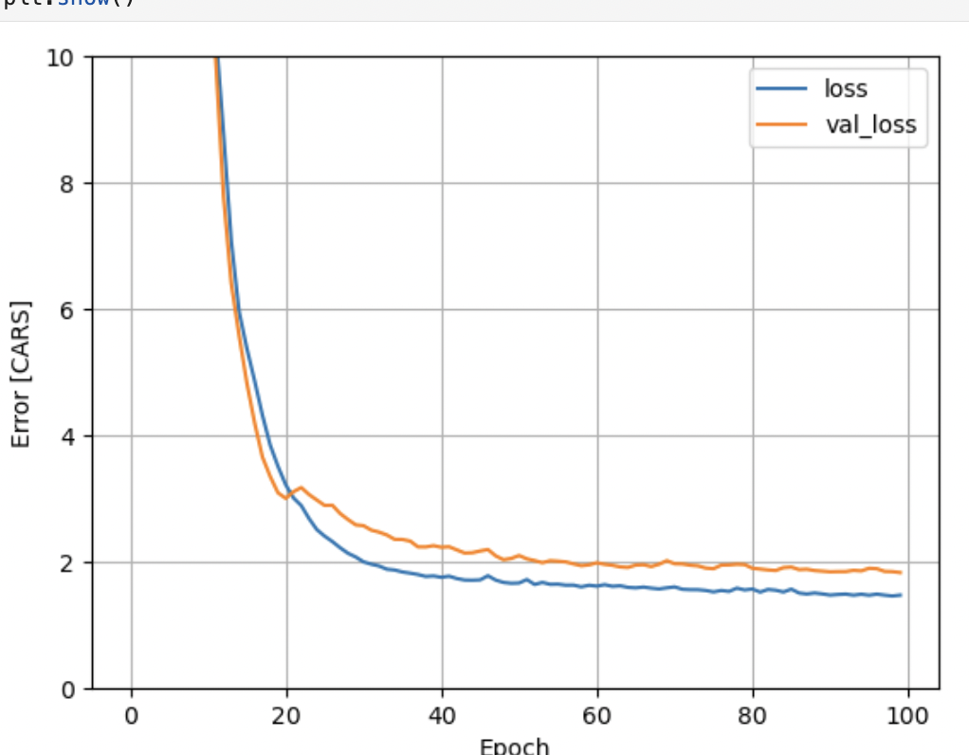

1. **True Value Vs Predicted Value:**

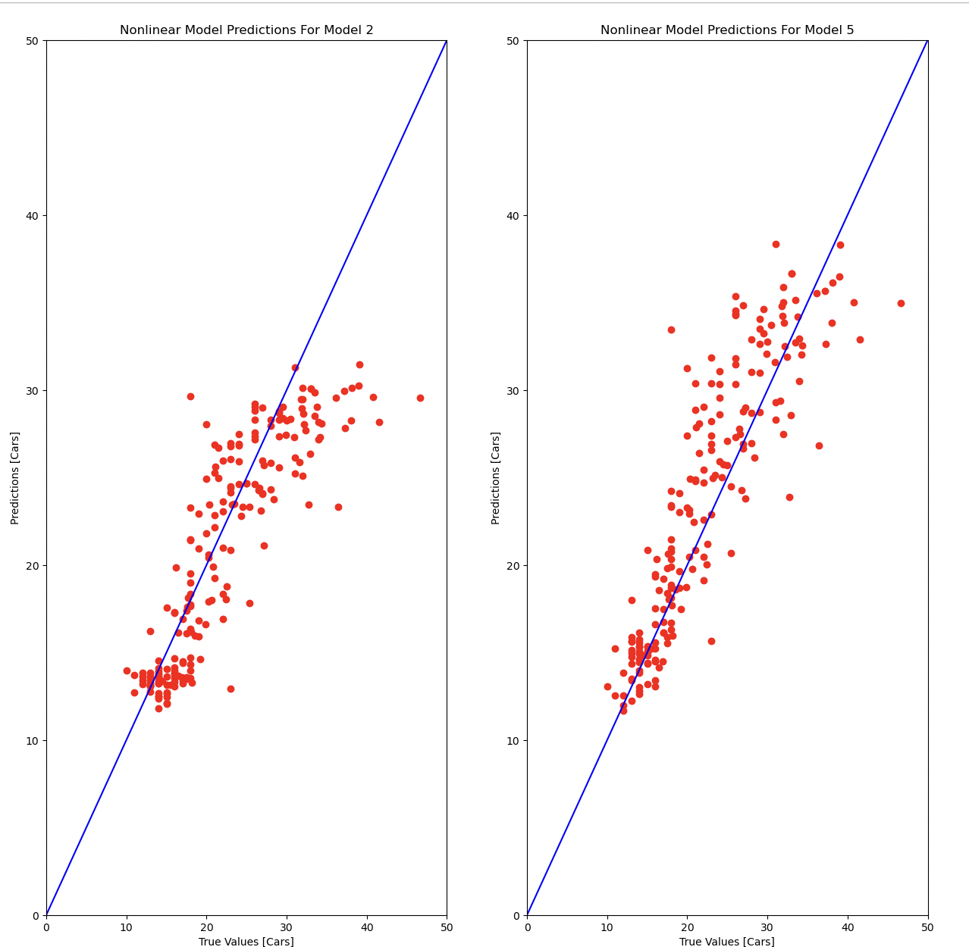

* Here I present an example how Logistic Regression can be used to predict a car Based on America (USA) according to its Horsepower and Weightlbs And Year. Also, a data standardization technique is evaluated. For this particular dataset, the standardization has no effect on model accuracy.
* The decision boundary between the two labels of data clusters (Truth Value And Predicted Value ) has been calculated and plotted using two techniques.
* During  evaluation of the model, The error terms are normally distributed with mean approximately 0.There is little correlation between the predictors.
* Despite being the most straightforward model we have created so far, the final predictors still appear to have substantial correlations. Although some of these features can be removed, the adjusted-r2 score will be considerably impacted.

**3) Additionally, the firm would like to understand how the variables recorded in the dataset affect mpg.**

* Prior to data science becoming widely used, reports given to internal or external clients were the main instances when data quality was discussed. These days, internal datasets within an organisation are in high demand since machine learning requires a lot of training data. Additionally, analytics are continually hungry for data and on the lookout for data assets that may be valuable, which has sped up the adoption of new datasets or data sources that had not previously been investigated or exploited. Data management and appropriate procedures for maintaining good data quality are now more crucial than ever because of this development.
* Yes , The Answer The Variables Recorded In the dataset Would affect The Mpg Column datatype.
* Accuracy: The data, regardless of what it is, must be accurate.
* Relevance: The information must be appropriate for the intended usage.
* Completeness: There shouldn't be any missing numbers or records in the data.
* Timeliness: The information must be current.
* Consistency: The data has to have the required data format and be able to be cross-referenced with the same outcomes.

**CONCLUSION**

* So, we have seen the building and deployment process of a machine learning model.
* Well we’ve achieved what we set out to achieve. We have a fairly accurate linear regression model that will take in features of a car based on brands America(USA) with a fair amount of accuracy.
* I think the intriguing conclusions we came to through our EDA are more fascinating. I mean, I'm certainly pleased to give it to you.
* Correlation analysis determines how well a connection is fit by a straight line by examining the degree of association between two continuous variables.
* MPG is 66% greater in manual gearbox vehicles.
* MPG will drop by three when going from a 4 to a 6 cylinder engine.
* MPG is reduced by 2.47 when a car's weight is increased by 1000 lbs.
* A 10 horsepower increase in an automobile results in a 0.42 MPG reduction.
* According to the coefficient for the "year" variable, an increase of 1 year will typically result in a rise of 0.7507727 in "mpg" (all other predictors remaining constant). In other words, cars improve their fuel economy by almost 1 mpg annually.
* Even though we could have continued to train other models like the Adaboost and XGboost which could have given a better accuracy and minimized error as compared to our final GradientBoosting model but I choose to end here.